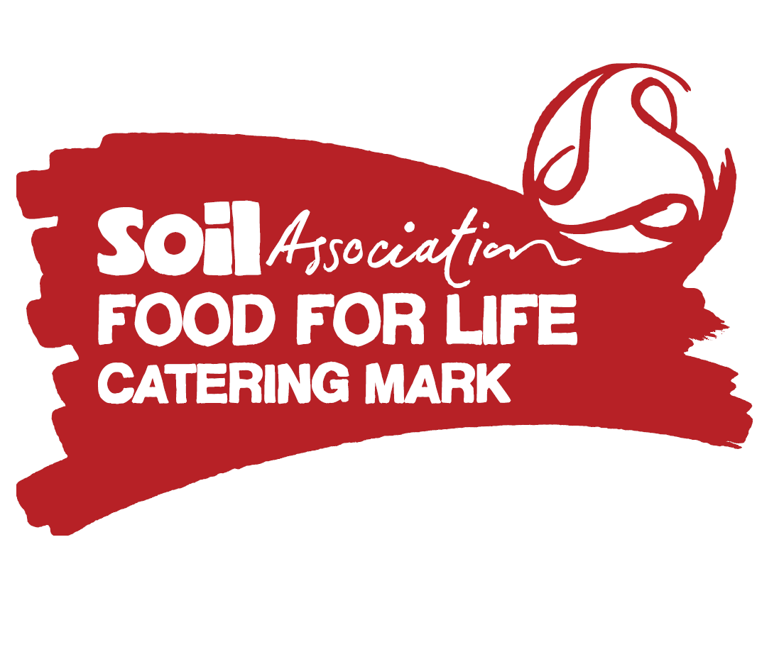
The University of Edinburgh
Sustainability Operations Advisory Group (SOAG)
Wednesday 27 May 2015
Edinburgh Food for Life Partnership (EFfLP)

Description of paper
This paper reports on the key achievements of collaborative work carried out under the Edinburgh Food for Life Partnership from 2012-2015:
- First higher education institution in Scotland to be the awarded the Catering Mark
- Strong strategic food-based relationships established across public sector in Edinburgh through EFfLP and Edible Edinburgh – sustainable food city initiative
- Regular student engagement, especially of first year students, helping embed Food for Life values
- One million meals served each year by the University – comprising 5% of Catering Mark meals served in Scotland – with a benefit to thousands of consumers.

Action requested
SOAG members are invited to note the report and commend those who participated.

Background
The University was a founding member of the Edinburgh Food for Life Partnership (EFfLP), an ambitious public sector collaboration between City of Edinburgh Council, NHS Lothian, the University (UoE) and Soil Association Scotland initiated in 2012 – with four central aims:
- Tackle barriers to providing seasonal, fresh, local and organic food
- Achieve a Food for Life Catering Mark award for catering services in selected sites
- Support children and young people, patients, students and staff to benefit from healthier and more sustainable food
- Evaluate the impact of the project.
Participating in and supporting the EFfLP helped the University demonstrate leadership around key food issues, becoming the first University in Scotland to hold the Catering Mark award in late 2012. Other Scottish firsts for the partnership included first “All Schools” award and first Care Home, both awarded to City of Edinburgh Council.
Following the Catering Mark award, the University further demonstrated its commitment by providing strategic support through the Governance Group for senior representatives – initially Senior Vice Principal Professor Mary Bownes and later Dave Gorman, Director of Social Responsibility and Sustainability.
The University supported student engagement and Soil Association Scotland became involved in a campus-wide food group and contributed to the University’s draft Sustainable Food Systems Policy.
Food for Life Scotland’s national programme has benefitted from seeing first-hand the practical and financial challenges associated with making changes to large scale catering services – particularly those operating in a competitive urban setting.
Discussion
Considerable progress was achieved over the three years against the original aims:
Tackle barriers to providing seasonal, fresh, local and organic food
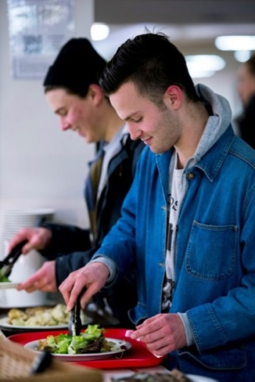
- Several challenges were identified and overcome, such as the requirement to serve only “farm assured” meat at sites with the award and how to display the provenance of produce for consumers. This work involved staff from across the University, including Social Responsibility and Sustainability, Catering, Procurement and Accommodation Services departments.
- A key barrier was how to make the necessary changes to the campus café menus, which operate in a very competitive “high street” environment. This was overcome, with Accommodation Services achieving the Bronze Award for twelve outlets in 2013.
- Strategic level “Governance Group” meetings between senior level representatives from across the EFfLP helped join up the work as well ensuring continued senior level buy-in and strategic direction. These meetings ensured that the work matched strategic aims.
- UoE hosted a Governance Group meeting at Pollock Halls with a presentation by Soil Association’s Standards Manager on standards development within the Catering Mark. This ensured that the catering management were aware of the rationale and process behind the standards required to achieve the Catering Mark award.
- Food for Life staff provided feedback on the University’s draft Sustainable Food Systems Policy – supporting values around health and sustainability.
Achieve a Food for Life Catering Mark award for catering services in selected sites
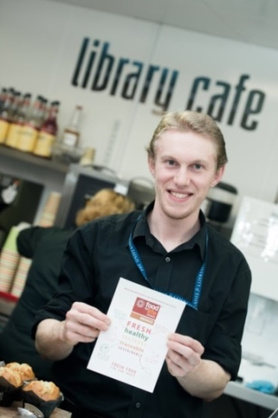
- UoE became the first University in Scotland to achieve the Catering Mark award in December 2012. The award was for the John McIntyre Conference Centre (JMCC) at Pollock Halls of Residence – serving 4,000 meals each day.
- To achieve the Bronze Award, UoE met 13 standards including a minimum percentage of freshly prepared meals, seasonal menus, using farm assured meat and displaying information about the provenance of the ingredients: www.sacert.org/catering/standards.
- The Catering Mark was renewed in December 2013 when the Award was extended to include twelve cafes run by Accommodation Services on campus. This was a Scottish first and a significant achievement given the commercial challenges facing these outlets.
- The Award now covers one million meals served each year by the Accommodation Services – representing 5% of Catering Mark meals served in Scotland.
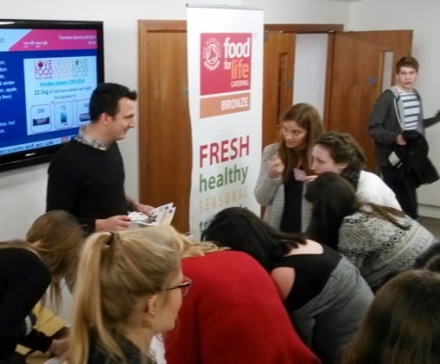
Support children and young people, patients, students and staff to benefit from healthier and more sustainable food
- Students and other customers of the commercial outlets are benefiting from healthier and more sustainable food.
- FfLS created a range of printed materials including table talkers, posters, a banner stand and an animated “Prezi” for displaying on the foyer screen at Pollock Halls. These helped promote the award to students and conveyed Food for Life values such as the importance of healthy, seasonal and ethical food.
- Regular student engagement events were held at Pollock Halls of Residence throughout 2013 and 2014. These included a series of competitions, interactive sessions and other awareness raising activities, including providing information about animal welfare, farm assurance and inviting / enabling students to write their own views on food issues.
- The University gained positive press coverage including Edinburgh Evening News, The Times and some trade press stories.
- In August 2014, a report was published on the national Food for Life Scotland website, promoting a message about farm assured and traceable meat to a wider audience.
- FFLS provided updated marketing materials for students at Pollock Halls for each of the new academic years, helping ensure momentum for the engagement process.

Evaluate the impact of the project
- An evaluation report detailing the outcome of the engagement events and surveys is available separately.
- An evaluation of the national programme by Food for Life Scotland covered impact on school meals. One of the geographical areas for evaluation was Edinburgh.
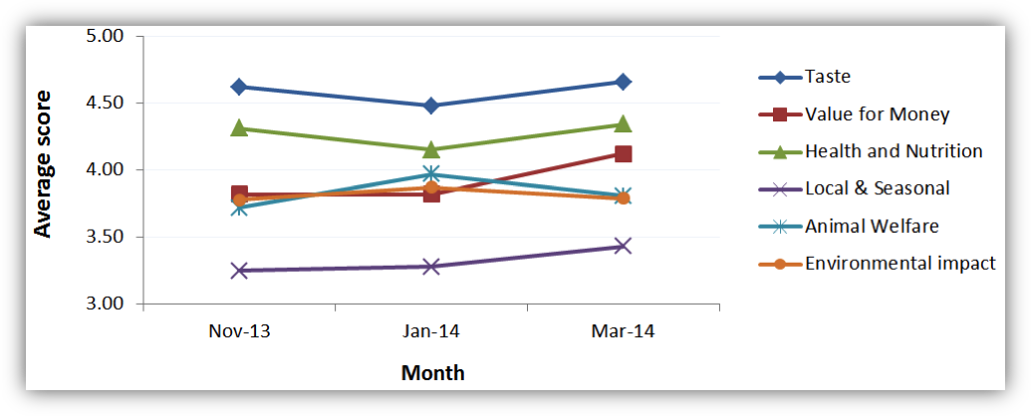
A chart within evaluation report showing how students rate food issues over time

“The Food for Life Scotland team helped raise awareness of animal welfare and other issues through a series of engagement events within our catering halls, as well as gathering information about what matters to our students.”
Ian Macaulay, Assistant Director – Catering, Accommodation Services

Conclusion
A number of positive changes have been made as a result of the work between the University and FfLS and significant challenges have been overcome – not least procuring farm assured meat which ensures traceability. Having the Catering Mark has increased recognition of the high quality catering service provided through the publicity achieved.
There were some internal tensions regarding the implementation of standards which meant that going beyond Bronze level was not prioritised. This also meant that promotion and marketing plans were scaled back from those put forward initially by FfLS. Despite this, there was a clear overlap between UoE and FfLS values and principles with local sourcing and using fresh produce already a priority for UoE before the work began.
There is an opportunity for further focus on local food, healthy eating and ethical sourcing. There is also scope to work together more on student and / or staff engagement, for example by using some of the materials and techniques employed by Food for Life Scotland’s Education Framework which is working with learners of all ages, including at tertiary level, to help transform Scotland’s food culture.
There is also potential to link more closely with the Healthy Universities Network. The Healthy University Project is currently running at UoE. This partnership could help drive a “whole university approach” to food and its connection with sustainability and health.
Soil Association Scotland acknowledges the contribution by key staff at the University and the funding and effort towards work undertaken to date. All partners hope to see the work continue to help support strategic aims regarding food procurement, catering and education and to use Food for Life Catering Mark as a key supporting mechanism for delivering real change in Scotland’s capital.
“It is increasingly important that all our customers know where their food is from and there are clear means of traceability – something the Catering Mark ensures”.
Ian Macaulay, Assistant Director - Catering, Accommodation Services

Risk Management
Provision of high quality food on campus contributes to the University’s objective to offer an outstanding student experience and this will continue to be a priority.

Equality & Diversity
Provision of food attractive to the very diverse cultural mix of especially international students and staff will be a growing focus for the future.

Next steps / implications
Accommodation Services have continued to innovate in ensuring high standards are recognised and was awarded the Sustainable Restaurant Award for facilities at Pollock Halls in April 2015.

Consultation
The paper was drafted by Joe Hind, Supply Chain Manager, Food for Life Scotland, and edited to reflect UoE priorities following comments from SRS & Accommodation Services.

Further information
To be presented by Dave Gorman, Director of Social Responsibility and Sustainability
19 May 2015

Freedom of Information
This is an open paper.

